A495-AM,N-NW-Quileute-Totem Pole-Cedar wood-early 19th century

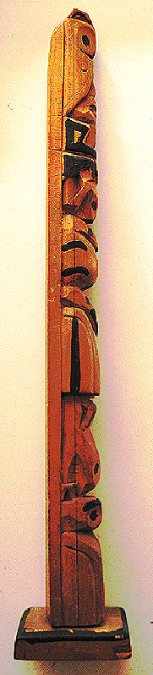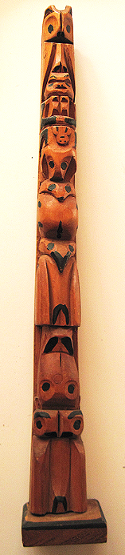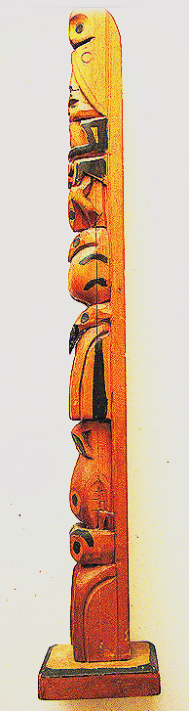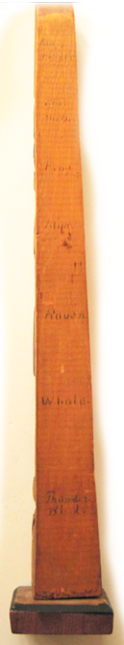

Figs. 1-4. Quileute-Totem Pole-Thunderbird-Whale-Raven-Mink- Frog-Bear Mother- King Fisher-Cedar wood-19th century

**Case no.: 8**

**Accession Number: A495**

**Formal Label:** Quileute-Totem Pole-Thunderbird-Whale-Raven-Mink- Frog-Bear Mother- King Fisher-Cedar wood-19th century

**Display Description:**

The Quileute (Quillayute), a First Nation in western Washington State had whaling families that were being deprived of hunting whales by a monster sperm Whale, who was killing lesser whales and depriving the People of whale meat and whale oil. Thunderbird was a supernatural being who lived in the Cascade Mountains, and saw from his high perch that the People were starving. So he flew over Puget Sound, found and seized Whale, and engaged in a momentous struggle to lift Whale out of the water. When Thunderbird released Whale over land thunder was heard, then he released Whale over water and thunder was heard again, and this continued for a long time until a Vancouver Island boy saw Thunderbird seizing and dropping Whale. Thunderbird saw the boy and told him that this story was now his, and he had the right to wear the Thunderbird mask and wings at the potlatch and to re-enact Thunderbird’s battle for his People, so that each time he would flap his wings thunder could be heard by Raven, Mink, Frog Bear Mother and King Fisher, so the whole of Creation would appreciate the recurrent sound of thunder of Thunderbird the Creator and not the exceptionalism of each clap.

**LC Classification:** E99.Q5

**Date or Time Horizon:** 19th century

**Geographical Area:** Pacific Northwest

**Map, GPS coordinates:** Puget Sound

**Cultural Affiliation:** Quileute Totem Pole

**Medium:** cedar wood

**Dimensions:** 393.45 mm, 14.7 in

**Weight:** 373.45 gm, 3.25 oz

**Condition: original**

**Provenance:** Everett Cherrington Hughes, 1922-1982

**Discussion:** The sociological message of the Quileute-Totem Pole myth coincided with Hughes’ method of gradually exposing an entire field study group to its individual components and of how they were affected by each separate entity as not as exceptional components but integral to a larger *experiential* *core*.

In the Quileute-Totem Pole myth all seven entities are part of the larger totemic structure. This would counter those who see in Hughes’ orientation a search for a broader *theoretical* core rather than seeing his orientation to a broader *methodological orientation* to sociological fieldwork: a theoretical frame of reference that informs classical ecological theory (human ecology, functionalism, and a Weberian analysis of class, status and political power) with a proto-dependency analysis based on the 1930’s industrialization of Quebec, in particular (Helmes-Hayes 2000). Says Hughes to this, “if one quite clearly sees something happen once, it is almost certain to have happened again and again. The burden of proof is on those who claim a thing once seen is an exception; if they look hard, they may find it everywhere, although with some interesting differences in each case” (Hughes 1984, xviii-xix).

**References:**

Powell, J. V. and Vickie Jensen. 1976. *Quileute: an introduction to the Indians of La Push.* Seattle: University of Washington Press.

Helmes-Hayes, Richard. 2000. “The concept of social class: The contribution of Everett Hughes,” *Journal of the History of the Behavioral Sciences*, 36(2): 127-147.

Hughes, Everett Cherrington and David Riesman. 1984. *The sociological eye*. New Brunswick, NJ: Transaction Books.